Multi-Modality Species Detection Heatmaps
Visualizing Detection Patterns Across Drone, Bioacoustic, and Camera Trap Data

Executive Summary
This report presents a comprehensive analysis of wildlife detection patterns using heatmap visualizations across three distinct monitoring modalities. The analysis covers data from The Wilds conservation area, including aerial drone surveys of Père David's Deer, bioacoustic recordings of bird species, and camera trap photographs capturing deer and other wildlife.
Key Findings:
- 18,094 total Père David's Deer detections from drone footage with 76.7% frame detection rate
- 15 bird species identified from bioacoustic recordings, with European Starling most common (61 detections)
- 3,627 camera trap detections across 1,370 unique images from 3 camera locations
- Peak activity at 17:00 (5 PM) for camera trap wildlife detections

Data Overview
The analysis integrates three complementary wildlife monitoring approaches, each providing unique temporal and spatial perspectives on animal activity patterns.
Modality | Time Range | Total Detections | Species/Items
Drone Video | ~6 minutes (July 1, 2025) | 18,094 | Père David's Deer
Bioacoustic | 45 min (June 30, 2025) | 135 | 15 bird species
Camera Trap | 28 days (Aug-Sep 2025) | 3,627 | Deer, Birds

Heatmap 1: Drone Video Detection

What It Shows
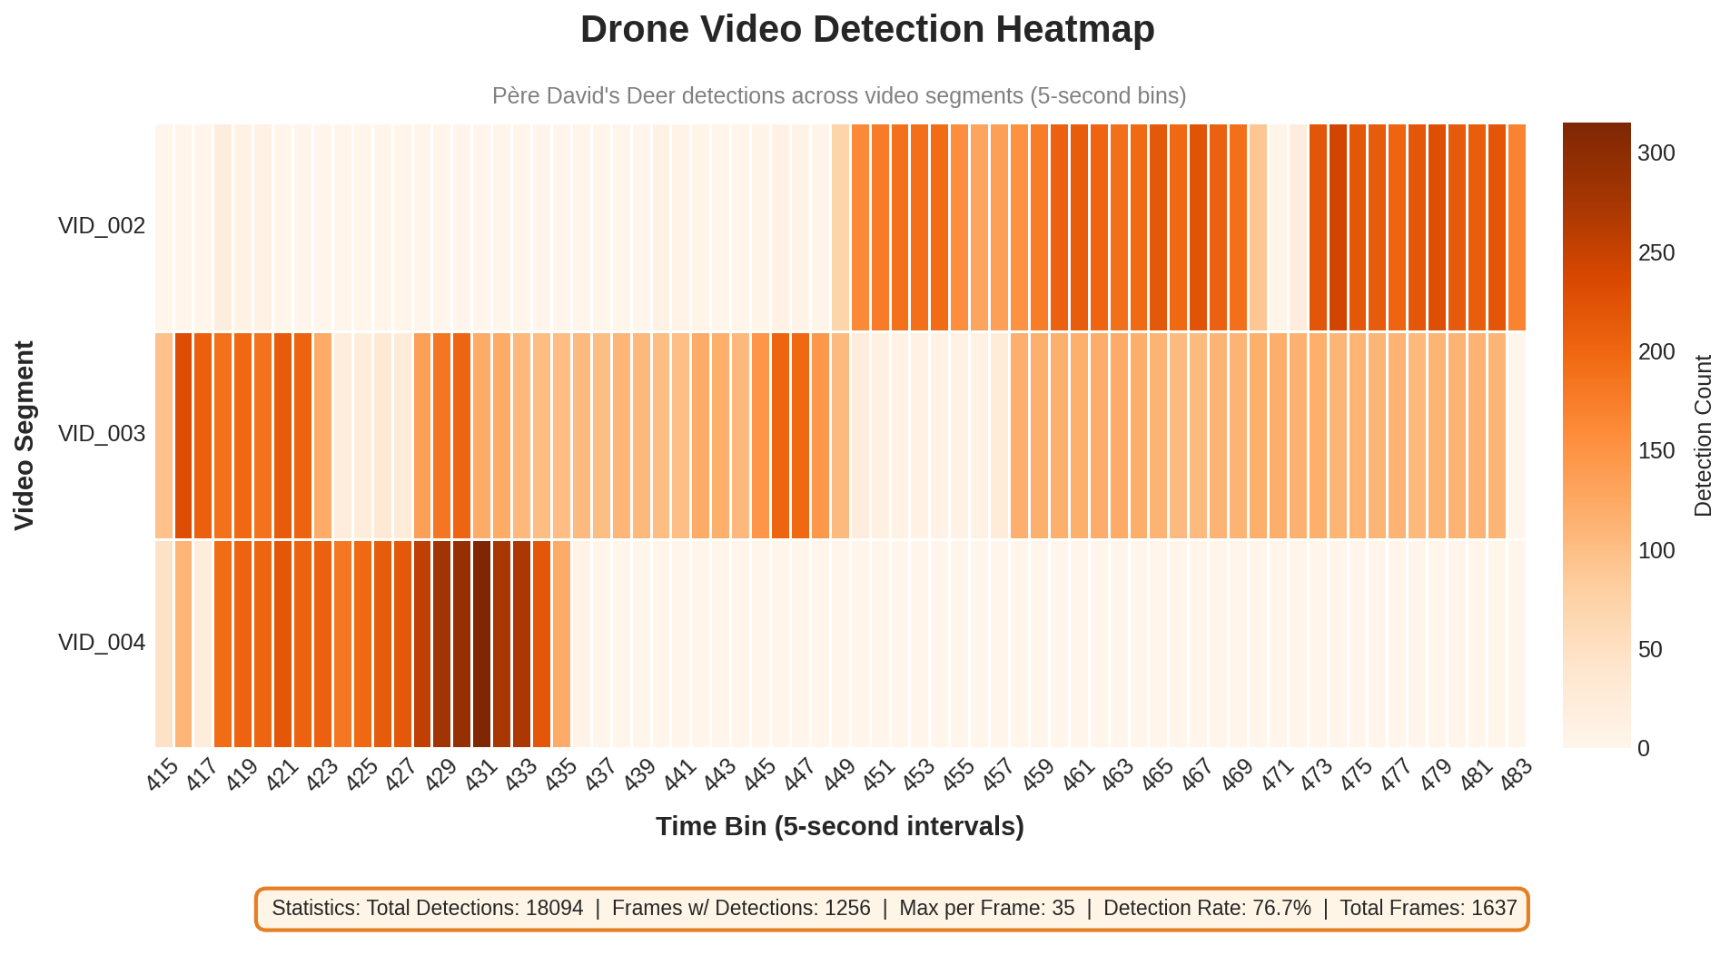
This heatmap displays Père David's Deer detections from aerial drone footage, with video segments (VID_002, VID_003, VID_004) on the Y-axis and time bins (5-second intervals) on the X-axis. Color intensity represents the number of deer detected in each time-video combination.

Structure
- Y-axis: Video segments (VID_002, VID_003, VID_004)
- X-axis: Time bins (5-second intervals from 415 to 483)
- Color Scale: Orange gradient (0-300 detections per bin)
- Colormap: Oranges - chosen to represent warm-blooded mammal activity

Key Insights
- Detection Hotspots: VID_004 shows the most intense detection hotspots (darkest bands, max 35 animals/frame), indicating the drone flew directly over a deer herd during this segment.
- Temporal Patterns: Detections are not evenly distributed - there are clear clusters and gaps, suggesting deer are grouped in specific locations rather than spread uniformly across the landscape.
- High Detection Rate: 76.7% of frames contained at least one deer, with up to 35 animals detected in a single frame, demonstrating the effectiveness of aerial surveys for this species.
- Video Comparison: VID_003 captured 7,522 total detections (mean 11.2 per frame) compared to VID_002's 6,321 and VID_004's 4,251, suggesting different habitat quality or herd locations along the flight path.

Statistics
Total Detections | 18,094
Frames with Detections | 1,256 of 1,637 (76.7%)
Max per Frame | 35 animals
Duration | 08:34:38 to 08:40:18 (~6 min)

Heatmap 2: Bioacoustic Detection

What It Shows
This heatmap visualizes bird species detected from audio recordings over a 45-minute evening session. Each row represents a different bird species, and each column represents a recording timestamp. Color intensity indicates the count of vocalizations detected.
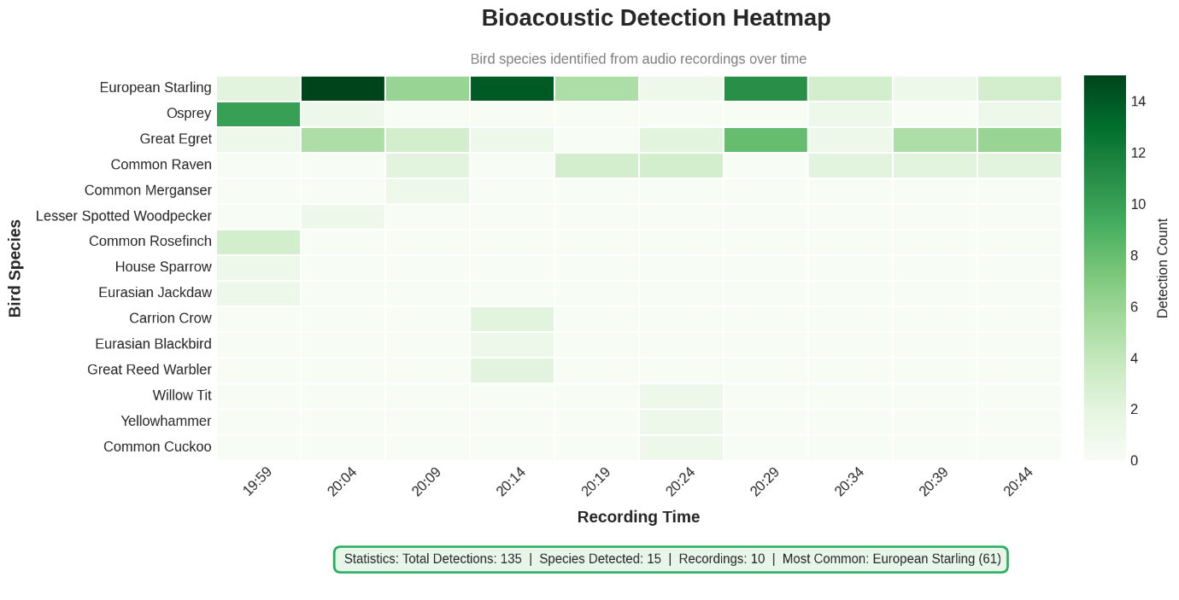

Structure
- Y-axis: 15 bird species (European Starling, Osprey, Great Egret, Common Raven, etc.)
- X-axis: Recording timestamps (19:59 to 20:44)
- Color Scale: Green gradient (0-14 detections)
- Colormap: Greens - chosen to represent avian/nature theme

Key Insights
- Dominant Species: European Starling dominated the recordings with 61 total detections, showing consistent activity throughout the entire recording session (darkest green row).
- Temporal Activity Shift: Osprey showed a distinctive pattern - highly active early (10 detections at 19:59) then dropped off dramatically, suggesting they may have departed the area or ceased vocalizing as evening progressed.
- Species Diversity Window: The 20:24-20:39 period shows the highest species diversity, with multiple rare species (Common Cuckoo, Yellowhammer, Willow Tit) appearing only during this window.
- Rare Species Detection: Several species appeared only once (Common Merganser, Lesser Spotted Woodpecker, House Sparrow), highlighting the importance of continuous monitoring to capture rare vocalizations.

Statistics
Total Detections | 135
Species Detected | 15
Recordings | 10
Most Common Species | European Starling (61)

Heatmap 3: Camera Trap Photo Detection

What It Shows
This heatmap displays wildlife detections by species across all 24 hours of the day, aggregating data from approximately one month of camera trap monitoring (August 11 - September 7, 2025).
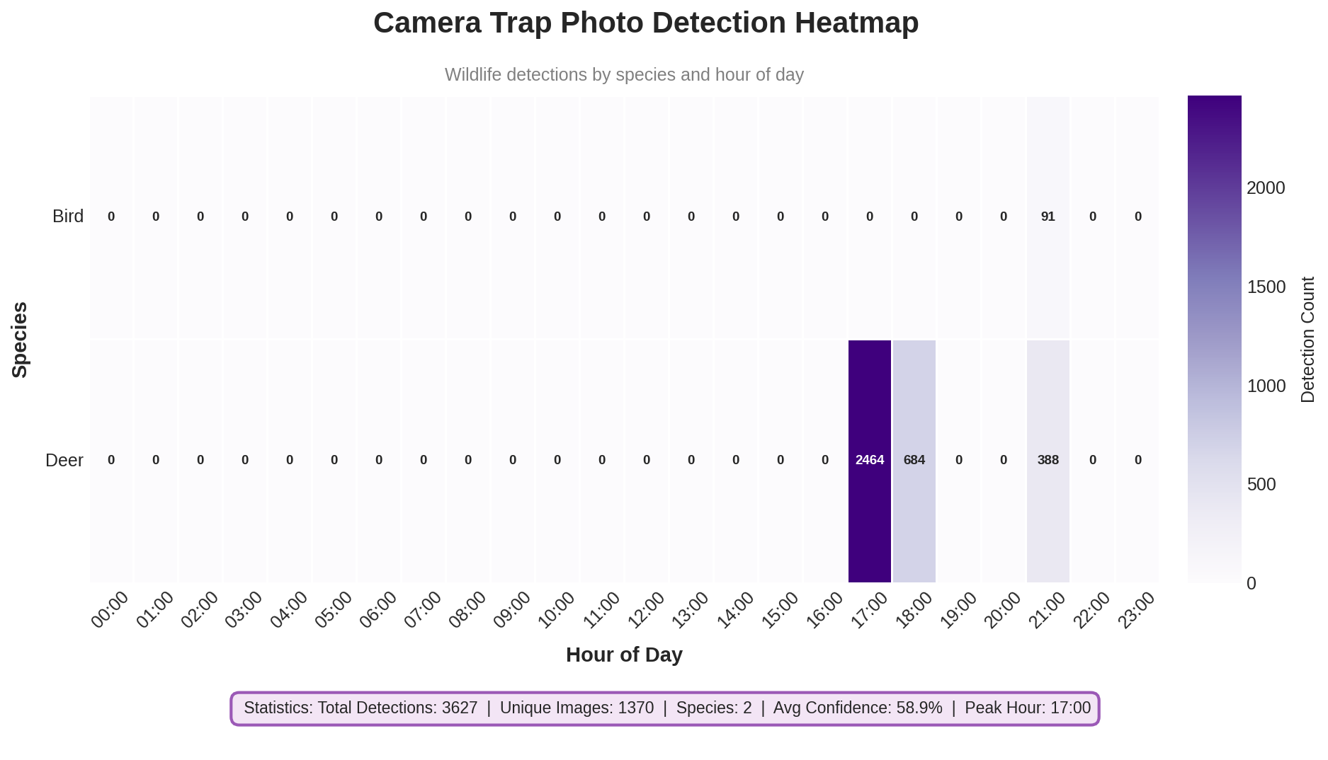

Structure
- Y-axis: Species groups (Bird, Deer)
- X-axis: Hour of day (00:00 to 23:00)
- Color Scale: Purple gradient (0-2000+ detections)
- Colormap: Purples - chosen to distinguish camera trap data from other modalities

Key Insights
- Crepuscular Activity Pattern: Deer show a strong late afternoon peak (17:00-18:00) with 2,464 detections at 5 PM and 684 at 6 PM. This indicates crepuscular (twilight-active) behavior typical of white-tailed deer.
- No Daytime Activity: Zero detections from midnight through 4 PM (hours 00:00-16:00) for deer. This could indicate either: (1) deer avoid these areas during daylight, or (2) camera deployment/sensitivity during these hours.
- Bird Detection Timing: Birds were only detected at 21:00 (91 detections), suggesting either nocturnal species or limitation in bird detection during other hours.
- Species Dominance: Deer dominate the detections (97.5% of total), with birds representing only 2.5%, reflecting the camera placement in deer habitat.

Heatmap 4: Camera Trap Activity by Location

What It Shows
This heatmap compares detection activity across the three camera trap locations (TW01_CT02, TW02_CT01, TW11_CT06) throughout the 24-hour day cycle.
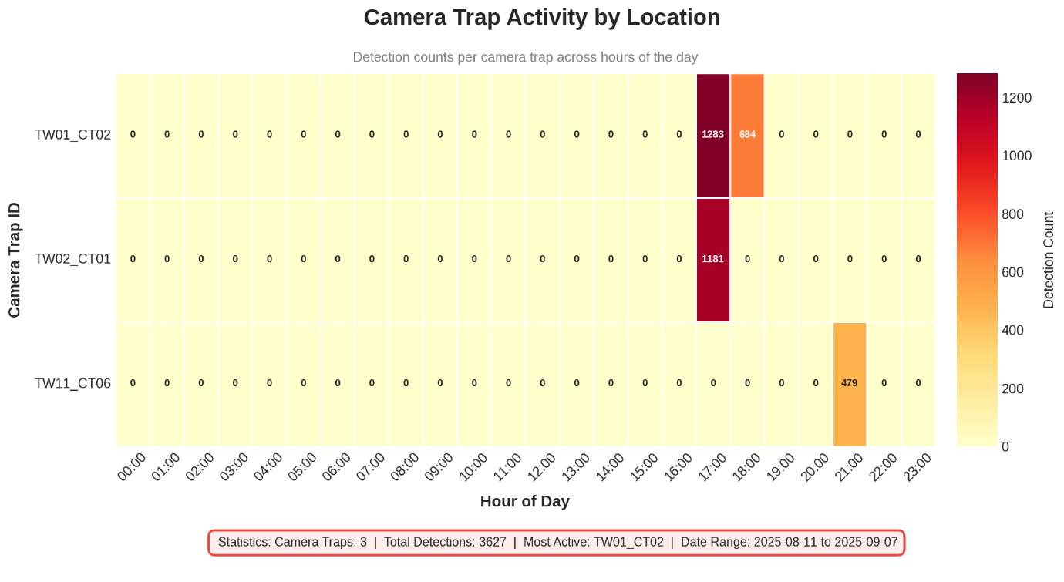

Structure
- Y-axis: Camera trap IDs (TW01_CT02, TW02_CT01, TW11_CT06)
- X-axis: Hour of day (00:00 to 23:00)
- Color Scale: Yellow-Orange-Red gradient (0-1200 detections)
- Colormap: YlOrRd - heat map style to emphasize activity hotspots

Key Insights
- Best Performing Camera: TW01_CT02 captured the most detections (1,967 total) with peak activity at 17:00 (1,283 detections) and 18:00 (684 detections). This camera is clearly positioned in a high-traffic deer corridor.
- Single-Hour Concentration: TW02_CT01 captured all 1,181 detections in a single hour (17:00), suggesting either: (1) a brief but intense deer movement event, or (2) camera operational issues during other hours.
- Evening-Only Activity: TW11_CT06 only captured activity at 21:00 (479 detections), uniquely positioned for evening/nocturnal wildlife. This is the only camera that captured bird detections.
- Habitat Differentiation: The three cameras appear to monitor different habitat types or wildlife corridors, with distinct temporal signatures suggesting varied ecological roles.

Heatmap 5: Detection Confidence Distribution

What It Shows
This heatmap visualizes the distribution of BioCLIP model confidence scores by species, helping assess the reliability of automated wildlife identifications.
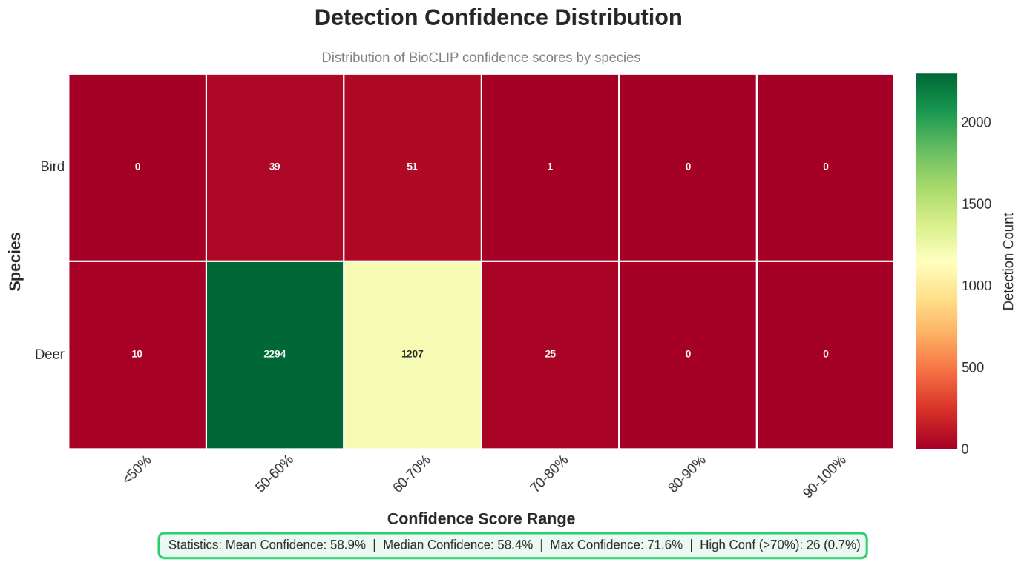

Structure
- Y-axis: Species (Bird, Deer)
- X-axis: Confidence score ranges (<50%, 50-60%, 60-70%, 70-80%, 80-90%, 90-100%)
- Color Scale: Red-Yellow-Green gradient
- Colormap: RdYlGn - intuitive red (low) to green (high) confidence spectrum

Key Insights
- Moderate Confidence Majority: Most deer detections (2,294 + 1,207 = 3,501) fall in the 50-70% confidence range, indicating the model is 'reasonably sure' but not highly confident about identifications.
- Very Few High-Confidence Detections: Only 25 deer detections (0.7%) exceed 70% confidence, and zero exceed 80%. This suggests opportunities for model improvement or indicates challenging image conditions.
- Bird Detection Quality: Bird detections peak at 60-70% confidence (51 detections), with slightly better relative performance than deer in the mid-confidence range.
- Model Calibration Opportunity: Mean confidence of 58.9% and median of 58.4% suggest the model may benefit from fine-tuning on local species variants or camera-specific image characteristics.

Heatmap 6: Multi-Modality Summary Dashboard

What It Shows
This combined dashboard presents simplified views of all three monitoring modalities side-by-side, enabling quick comparison of detection patterns and volumes across different data collection methods.
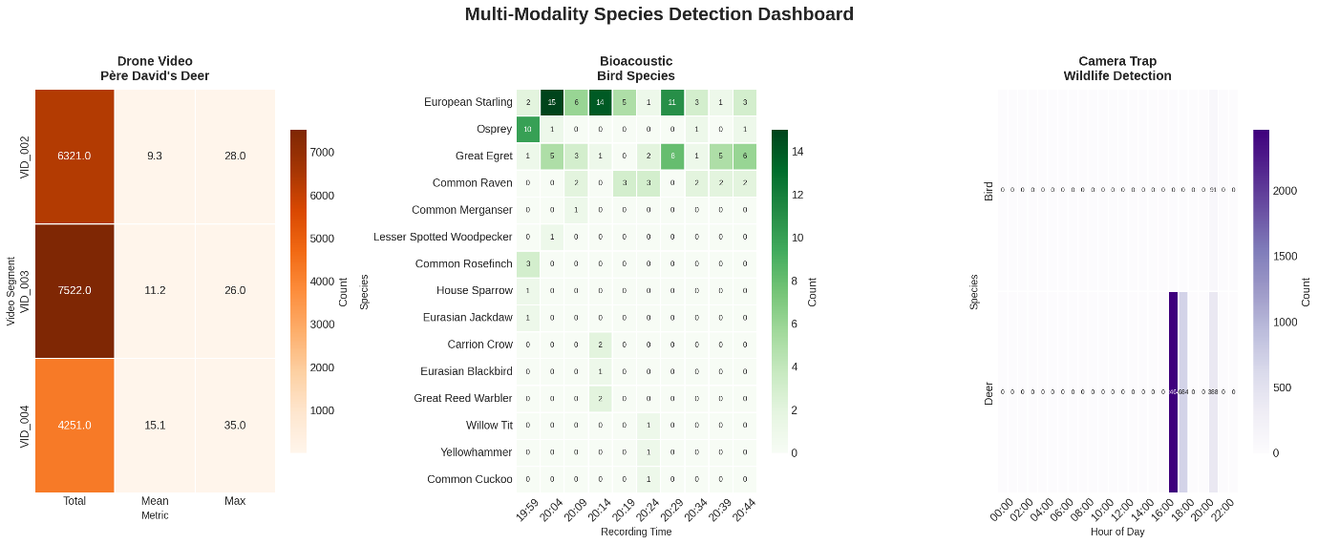

Key Insights
- Volume Comparison: Drone surveys captured the highest detection volume (18,094) in the shortest time (~6 minutes), demonstrating exceptional efficiency for large mammal surveys.
- Species Diversity: Bioacoustic monitoring provided the greatest species diversity (15 species) despite lower total detection counts (135), highlighting its value for biodiversity assessment.
- Temporal Coverage: Camera traps offered the longest monitoring period (~28 days), providing insights into day-to-day activity patterns not possible with point-in-time surveys.
- Complementary Strengths: Each modality tells a different story - drones for population counts, audio for species diversity, cameras for temporal behavior patterns. Together they provide comprehensive ecological understanding.

Conclusions and Recommendations

Summary of Findings
- Deer are most active during late afternoon (17:00-18:00), with strong crepuscular patterns visible in camera trap data.
- European Starlings dominate the bird community, accounting for 45% of all bioacoustic detections.
- Camera TW01_CT02 is the highest-performing location, capturing over half of all photo detections.
- Detection confidence averages 58.9%, suggesting opportunities for model improvement.
- Drone surveys achieve 76.7% detection rate, proving highly effective for Père David's Deer monitoring.

Data Summary
Heatmap | Dimensions | Output File
Drone Detection | Video × Time Bin | drone_detection_heatmap.png
Bioacoustic Detection | Species × Time | bioacoustic_detection_heatmap.png
Photo Detection | Species × Hour | photo_detection_heatmap.png
Camera Location | Camera × Hour | camera_location_heatmap.png
Confidence Distribution | Species × Confidence | confidence_distribution_heatmap.png
Multi-Modality Dashboard | Combined View | multimodality_dashboard.png

